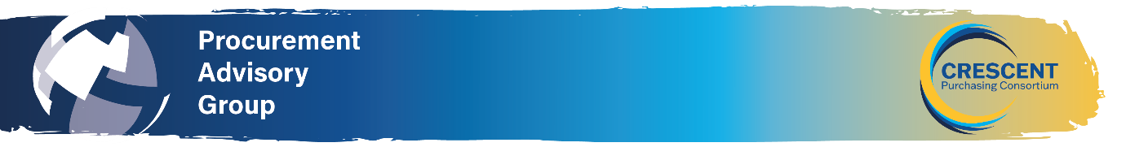
NORTH WEST REGIONAL PROCUREMENT ADVISORY GROUP MEETING
6th November 2025 at 10.30am - In person at Procurement House or via TEAMS
AGENDA
10:30 Meeting commencement
Apologies for absence and introductions
VICE CHAIR

Previous Minutes and National PAG Update
Review and agreement of previous minutes.
https://www.thecpc.ac.uk/aboutus/PAG/meetings.php

10.35 Maximising Social Value (30 Mins) – The Procurement Act 2023 provides an obligation to achieve social value were possible when awarding contracts. Discussion on how to include, evaluate and achieve social value. ( Danny Davies – Crescent Consultancy, Peter McMullan - Contracting Team, James Aldred – St Helen’s College)

CPC Contracting – Social Value Guidance:

- How does CPC deliver Social Value through its frameworks overview of our approach and key principles.
- Incorporating Social Value in a Mini or Further competition: Key considerations and recommended inclusions for Social Value supported by examples from a couple of frameworks.

Panel/members considerations for embedding Social Value in Procurement:

- Accessing whether Social Value requirement is suitable and proportionate to the nature, scope, and value of the contract.
- Quality evaluation criteria: what measurable questions to include in the tender documents when assessing bidders’ ability to deliver social value.
- Social Value KPIs: Have you developed specific Key Performance indicators to monitor delivery of social value?
- Evaluation: Do you use a specific scoring matrix to evaluate social value responses objectively and ensure transparency and fairness across bids?
- Contract Management: Have you established mechanisms to monitor and manage social value delivery throughout the contract lifecycle?
- What T&Cs: Have you embedded social value requirements into the contracts Terms and Conditions. Include clauses for non-delivery, remedies, and reporting obligations.

11.05 Minor Works DPS & Construction Framework/Facilities DM (20 mins) Keeley Blackburn, Ria Logan and Natalia Piecyk from the contracting team.
Overview of the minor works DPS and update on the new construction framework
- Benefits of using the DPS
- Lotting structure
- Engaging with local suppliers
- Criteria: Pricing, Added Value & Social Value

11.25 Update from Mark Pearson Learning & Development Lead on the new Crescent Learning site (20 Mins).

11:45 Round table discussion sharing knowledge and experiences and details of forthcoming procurement projects ALL (15 minutes) points for discussion:

- Roundtable discussion on how people are finding implementing PA23, and our initial lessons learned/observations.
- Colleges/Trusts to share details on procurement projects they will be working on with the aim of establishing whether there are any opportunities for collaborative purchasing.
- PAG –please provide suggestions on what you want from future PAG’s what topics you want on the agenda.

12:00 Any other business & Date, location of next meeting

