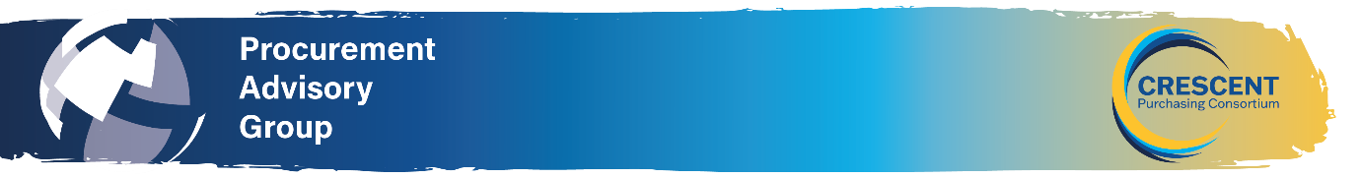
NORTH WEST REGIONAL PROCUREMENT ADVISORY GROUP MEETING
March 20th @10.30am - Virtual: Teams
AGENDA
10:30 Meeting commencement
Apologies for absence and introductions
CHAIR

Previous minutes and National PAG Update
Review and agreement of previous minutes.
https://www.thecpc.ac.uk/aboutus/PAG/meetings.php

10.35 Workshop from Jack Horton on Procurement Act 2024 – Update on where we are with the act, what has happened since go-live day, sustainability and social value in Procurement and the resources available via CPC.

This regional PAG will focus on information on the Procurement Act 2023 and its implementation, as well as Sustainability and Social Value in Procurement (what does it mean, what to include), along with an overview of the resources that will be available from CPC and on Crescent Learning that will help you and your institution moving into the new procurement landscape. You can influence the outcomes of the meeting, by discussing the elements for which you have most concerns.
We want you to influence the service you will receive over the next 12 months, and we will ask what you need from CPC and what you would like to see in terms of training.

11:30 Round table discussion sharing knowledge and experiences and details of forthcoming procurement projects ALL (25 minutes) points for discussion:

- PAG – what do you want from future PAG’s what topics you want on the agenda.
- Any burning issues within your college/trust you would like to discuss.
- Colleges/Trusts to share details on procurement projects they will be working on with the aim of establishing whether there are any opportunities for collaborative purchasing.

11:55 Any other business & Date, location of next meeting
- CPC Contracting Team feedback/engagement on upcoming contracts

END

