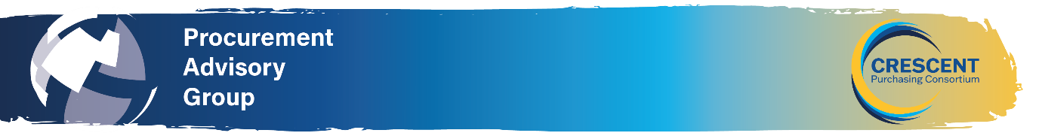
NORTH EAST REGIONAL PROCUREMENT ADVISORY GROUP MEETING
22 October 2025 at 10.30am - In person at Gateshead College and via TEAMS
AGENDA
10:30 Meeting commencement
Apologies for absence and introductions
CHAIR

Previous Minutes and National PAG Update
Review and agreement of previous minutes.
CHAIR
https://www.thecpc.ac.uk/aboutus/PAG/meetings.php

10.45 New Crescent Learning Platform:
Mark Pearson the CPC Learning & Development Lead will provide an overview of the new
Crescent Learning Platform which can be found on the CPC website.
https://www.thecpc.ac.uk/learning

11.05 Maximising Public Benefits:
This group discussion session will focus on maximising public benefits to prioritize outcomes that deliver the greatest positive impact for the public when awarding contracts, hence going beyond focussing on lowest price. The Procurement Act 2023 provides a platform to promote maximising public benefit by requiring the public sector to consider the importance of it when making procurement decisions. This can be achieved by focussing on the below points for discussion:

- Social value
- MAT
- Value for money

11:45 Round table discussion sharing knowledge and experiences and details of forthcoming procurement projects ALL - points for discussion:

- Roundtable discussion on how people are finding implementing PA23, and our initial lessons learned/ observations.
- Colleges/Trusts to share details on procurement projects they will be working on with the aim of establishing whether there are any opportunities for collaborative purchasing.
- PAG –please provide suggestions on what you want from future PAG’s what topics you want on the agenda.

12:25 Any other business, date & location of next meeting.
END
.

